Todd,
Well, because TBR changed their mind about phasing out guidelines, we have to add them back to our website. So, if you could just add the guidelines subject to the page and add them to the table of contents as their own “section” it would be great. You do have the freedom to set this up as you see fit.

This is what it used to look like:
RSCC Policies & Guidelines
- Transmittal Form for Proposing/Revising/Reviewing RSCC Policies
- We now have the guideline transmittal form that you have already linked here
- TBR Policies
- RSCC Guidelines

I have a guideline ready to post for Marsha Mathews so if you could get this done fairly quickly it would be appreciated.

https://www.roanestate.edu/?6680-FacultyStaff
On this page add Guidelines to Policies i.e., RSCC Policies and Guidelines

https://www.roanestate.edu/policies/
Please “and Guidelines” to RSCC Policies on this page.

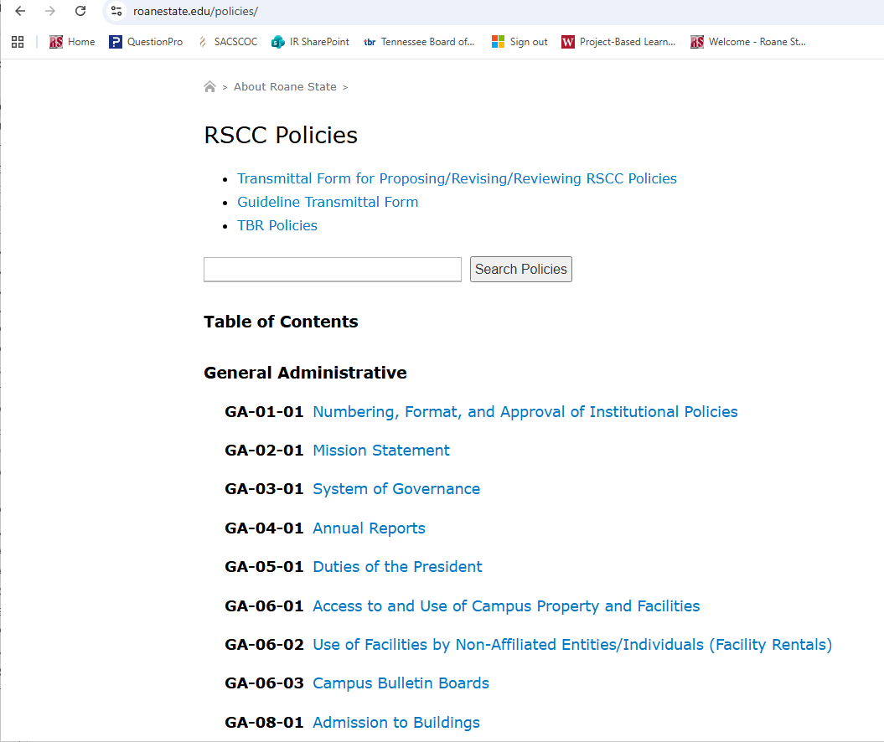

Thank you,
Anne Holder
Institutional Effectiveness and Research
Roane State Community College
276 Patton Lane
Harriman, TN 37748
Phone: (865) 354-3000, ext. 4224

