**CLINICAL CONTRACT TRANSMITTAL PROCESS**

**THE VP OF STUDENT LEARNING IS THE ONLY PERSON THAT HAS THE AUTHORITY TO SIGN CLINICAL AFFILIATION AGREEMENTS**. Please see policy G-34-01 for the complete list of individuals who have signature authority for certain types of agreements**.** [**https://www.roanestate.edu/?9271-RSCC-Policy-GA-34-01-Approval-of-Agreements-and-Delegation-of-AuthoritySignature-Authorization**](https://www.roanestate.edu/?9271-RSCC-Policy-GA-34-01-Approval-of-Agreements-and-Delegation-of-AuthoritySignature-Authorization)**.**

A Clinical Contract Transmittal form must be completed through Dynamic Forms for all clinical contracts and agreements that are **NOT** the standard approved TBR Clinical Contract.

The “Clinical Contract Transmittal Form” which links to **Dynamic Forms** can be found on Purchasing’s webpage under Contract Information and Templates or by clicking here: <https://dynamicforms.ngwebsolutions.com/Submit/Page?form=901a4075-0f86-4052-b5a3-fb2cf1cb93c8&section=368348&page=318411&token=-CAmA6a9iMWZXcQDLLSlq7-gjbyJCjoKVv6qrMuoEro>

The Clinical Contract Transmittal Form will be signed by the Submitter then sent on to the Dean of Health Sciences, Contract Officer and the VP of Student Learning for approval though Dynamic Forms. Please see **Attachment A for the Dynamic Forms** Contract process.

The Process

Specific actions on your part may speed up the review and approval process. Start the process as soon as possible. It takes time for reviews and approvals so plan to leave a reasonable amount of time for all of these steps to be completed. Timing for completing the process can vary widely depending on the extent of the contract, potential problems, and the vendors review of any amendments or changes that need to be made.

Most contracts that originate from another party are written to protect their interests and will likely include impermissible language. An amendment will need to be drafted and hopefully approved by the vendor unless they will remove the impermissible language.

The most common impermissible clauses are: indemnity, state of jurisdiction, warranty disclaimers, hold harmless clauses, attorney fees, and arbitration clauses. If you see headings or terminology such as this in your agreement, then it is probable that we will need to draft an amendment for the vendor to review. The negation of the amendments can take some time so plan accordingly.

**Make sure the facts, dates, etc. are accurate in your contract and be sure to complete any information that RSCC must provide. Fill in ALL the blanks within the contract.**

**Thank you for your help with the Contract Process!**

**ATTACHMENT A**

SUBMITTING CLINICAL CONTRACTS THROUGH DYNAMIC FORMS

1 – Go to the Purchasing Webpage by clicking the link below and choose “**Clinical Contract Transmittal Form”** under Contract Information and Templates: <https://www.roanestate.edu/?10825-Links-for-RSCC-Purchasers>. This takes you to the purchasing page where you will find the login for Dynamic Forms to start the process.

2 – You will NOT fill in the Contract number, this will be assigned by the Contract Officer.

3 – Fill in all that cells that relate to your agreement. The cells that have asterisks are required.

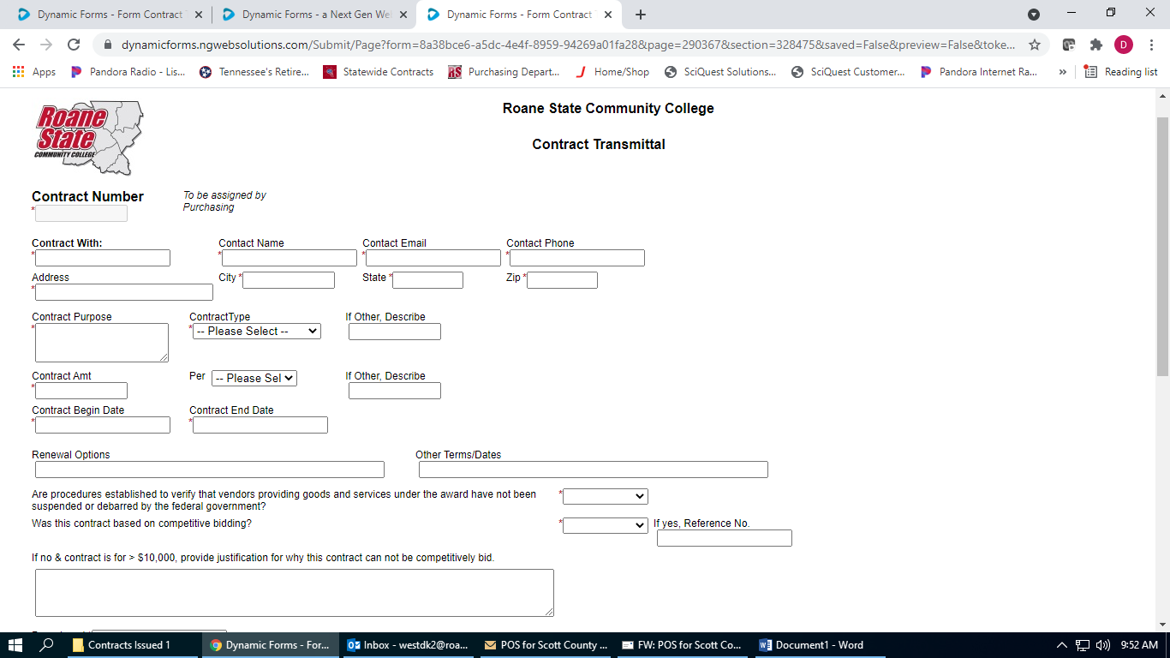

4 – Upload the agreement in the box as seen below.

5 – Electronically sign and hit the submit form button.

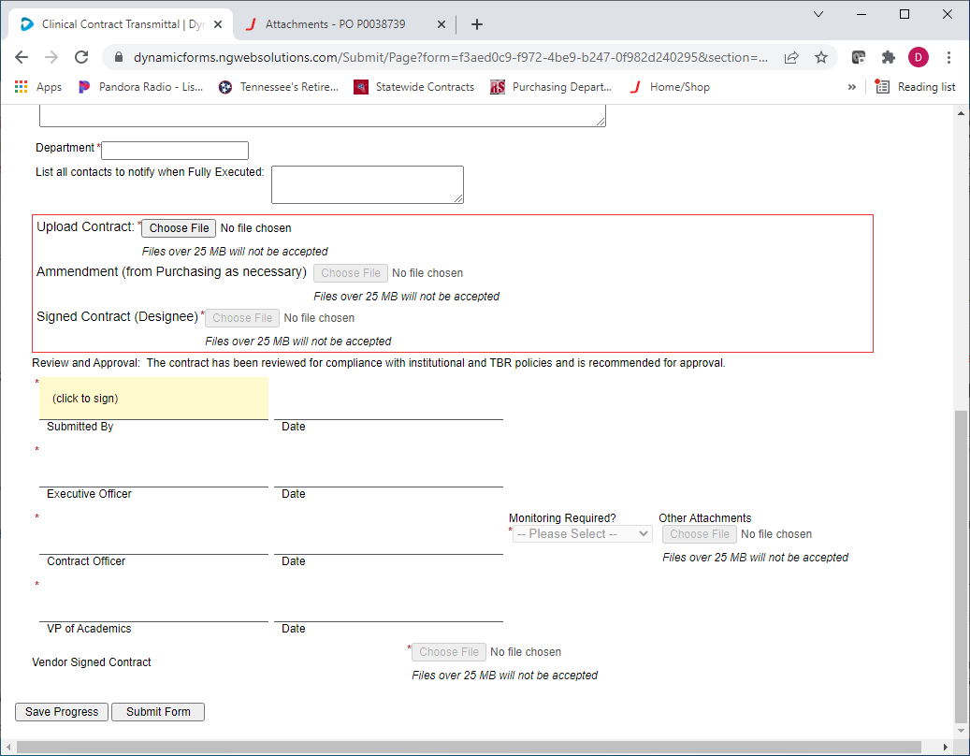

6 –At this point, the form will be sent to your Dean, Dr. Pat Jenkins, for review and signing.

7 – The form then goes to the Contract Officer (Dana West) to review the contract and draft any amendments that may be needed.

8 – Dana will send the amendment, if needed along with the contract to the vendor to be signed.

9 – After the contract and amendment are returned to Dana, she will upload the documents in Dynamic Forms. At this point, Dana will sign and submit the clinical contract transmittal form.

10 - The form will then go to the VP of Student Learning, Dr. Diane Ward, to review and then to Cathy Smith to place Dr. Ward’s signature on the contract.

11 – When this is complete, the submitter will receive the final documents back by Dynamic Forms through an email. You click on the link in the email which will route you to Dynamic Forms to see the completed contract as shown below. You will choose Forms History to view the documents and save as a pdf for your records.

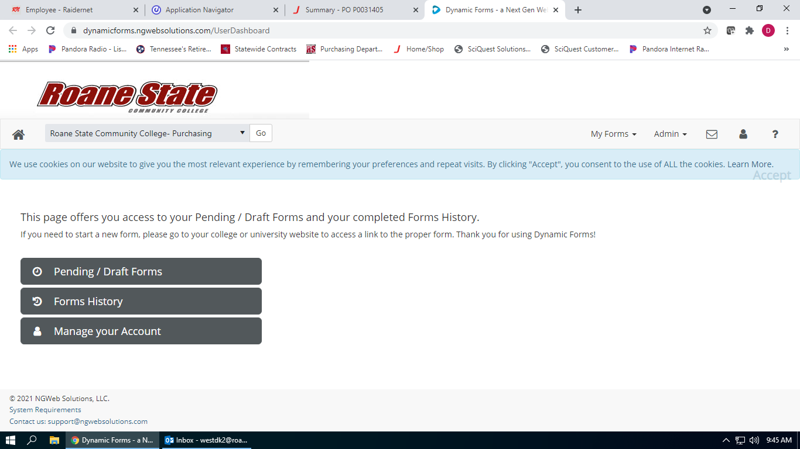

Please contact Dana West if you have any questions with this process at xt. 4657 or westdk2@roanestate.edu.