AGREEMENT

BETWEEN

ROANE STATE COMMUNITY COLLEGE

AND

_____________________________

THIS AGREEMENT, is made this ______ day of ____________________, 20__, by and between Roane State Community College, hereinafter referred to as the “Institution,” and, __________________________________________ hereinafter referred to as “Contractor.”

W I T N E S S E T H:

In consideration of the mutual promises herein contained, the parties have agreed and do hereby enter into this Agreement according to the provisions set out herein:

A. The Contractor agrees to perform the following services:

***(Detailed description, including type, scope, duration, form, quality, quantity, place, time, and purpose****)*

B. The Institution agrees to compensate the Contractor as follows:

1. ***(Rate of compensation – hourly, daily, etc.)***

2. ***(Timetable for payments, monthly, quarterly, after full performance, etc..)***

3. Payments to the Contractor shall be made according to the schedule set out above, provided that payments shall be made only upon submittal of invoices by the Contractor, and after performance of the portion of the services which the invoiced amount represents. The final payment shall be made only after the Contractor has completely performed its duties under this agreement.

If the Contractor is a non‑resident alien, payment of any portion of the contract from any source will not be made by the Institution until an Individual Taxpayer Identification Number or Social Security Number has been assigned to the Contractor by the Internal Revenue Service and Immigration Naturalization Service and presented to the Institution.

4. In no event shall the liability of the Institution under this Contract exceed $______________.

C. The parties further agree that the following shall be essential terms and conditions of this Agreement.

1. The Contractor warrants that no part of the total contract amount provided herein shall be paid directly or indirectly to any officer or employee of the State of Tennessee as wages, compensation, or gifts in exchange for acting as officer, agent, employee, sub‑contractor, or consultant to the Contractor in connection with any work contemplated or performed relative to this Agreement.

If the Contractor is an individual, the Contractor warrants that within the past six months he has not been and during the term of this Contract will not become an employee of the State of Tennessee.

2. The parties agree to comply with Title VI and VII of the Civil Rights Act of 1964, Title IX of the Education Amendments of 1972, Section 504 of the Rehabilitation Act of 1973, Executive Order 11,246, the Americans with Disabilities Act of 1990 and the related regulations to each. Each party assures that it will not discriminate against any individual including, but not limited to, employees or applicants for employment and/or students because of race, religion, creed, color, sex, age, disability, veteran status or national origin.

The parties also agree to take affirmative action to ensure that applicants are employed and that employees are treated during the employment without regard to their race, religion, creed, color, sex, age, disability, veteran status or national origin. Such action shall include, but not be limited to, the following: employment, upgrading, demotion or transfer, recruitment or recruitment advertising, layoff or termination, rates of pay or other forms of compensation, and selection available to employees and applicants for employment.

3. Prohibition on Hiring Illegal Immigrants. Tennessee Public Chapter No. 878 of 2006, TCA 12-4-124, requires that Contractor attest in writing that Contractor will not knowingly utilize the services of illegal immigrants in the performance of this Contract and will not knowingly utilize the services of any subcontractor, if permitted under this Contract, who will utilize the services of illegal immigrants in the performance of this Contract. The attestation shall be made on the form, Attestation re Personnel Used in Contract Performance (“the Attestation”), which is attached and hereby incorporated by this reference as Attachment I.

If Contractor is discovered to have breached the Attestation, the Commissioner of Finance and Administration shall declare that the Contractor shall be prohibited from contracting or submitting a bid to any Tennessee Board of Regents institution or any other state entity for a period of one (1) year from the date of discovery of the breach. Contractor may appeal the one (1) year by utilizing an appeals process in the Rules of Finance and Administration, Chapter 0620.

4. This Agreement shall not be binding until the Contractor has returned a completed minority/ethnicity report to the Institution. (Attachment II)

5. The Contractor, being an independent contractor and not an employee of the Institution, agrees to carry adequate public liability and other appropriate forms of insurance, to pay all taxes incident hereunto, and otherwise protect and hold the Institution harmless from any and all liability not specifically provided for in this Agreement.

6. The term of this contract shall be from _________________ to_______________.

7. This Agreement may be terminated by either party by giving written notice to the other, at least ___________ days before the effective date of termination. In that event, the Contractor shall be entitled to receive just and equitable compensation for any satisfactory authorized work completed as of the termination date.

8. If the Contractor fails to fulfill in a timely and proper manner its obligations under this Agreement, or if the Contractor shall violate any of the terms of this Agreement, the Institution shall have the right to immediately terminate this Agreement and withhold payments in excess of fair compensation for work completed.

Notwithstanding the above, the Contractor shall not be relieved of liability to the institution for damages sustained by virtue of any breach of this Agreement by the Contractor.

9. This Agreement may be modified only by written amendment executed by all parties hereto.

10. The Contractor shall maintain documentation for all charges against the Institution under this Agreement. The books, records and documents of the Contractor, insofar as they relate to work performed or money received under this Agreement, shall be maintained for a period of five (5) full years from the date of the final payment, and shall be subject to audit, at any reasonable time and upon notice, by the Institution or the Comptroller of the Treasury, or their duly appointed representatives.

11. The Contractor shall not assign this Agreement or enter into sub‑contracts for any of the work described herein without obtaining the prior written approval of the Institution. Approval shall not be given if the proposed subcontractor was or is currently ineligible to bid on the Contract.

12. The Contractor shall submit to the Institution ***(monthly) (quarterly)*** progress reports if requested by the institution.

13. This Agreement shall not be binding upon the parties until it is approved by the President or his designee.

14. Payment to the Contractor for travel, meals, or lodging, if authorized, shall be in the amount of actual cost or per diem, subject to the maximum amounts and limitations specified in the Tennessee Board of Regents policies, as they may be from time to time amended.

IN WITNESS WHEREOF, the parties have by their duly authorized representatives set their signature.

ROANE STATE COMMUNITY COLLEGE CONTRACTOR

_______________________________ ____________________________________

Dr. Chris Whaley, President Signature

____________________________________

Social Security Number

____________________________________

Street Address

____________________________________

City State Zip

Attachment I

|  |  |  |
| --- | --- | --- |
| **ATTESTATION RE PERSONNEL USED IN CONTRACT PERFORMANCE** | | |
| **CONTRACT NUMBER:** | |  |
| **CONTRACTOR LEGAL ENTITY NAME:** | |  |
| **FEDERAL EMPLOYER IDENTIFICATION NUMBER:** (or Social Security Number) | |  |
| **The Contractor, identified above, does hereby attest, certify, warrant, and assure that the Contractor shall not knowingly utilize the services of an illegal immigrant in the performance of this Contract and shall not knowingly utilize the services of any subcontractor who will utilize the services of an illegal immigrant in the performance of this Contract.** | | |
| **SIGNATURE & DATE:** |  | |
|  | NOTICE: This attestation MUST be signed by an individual empowered to contractually bind the Contractor. If said individual is not the chief executive or president, this document shall attach evidence showing the individual’s authority to contractually bind the Contractor. | |

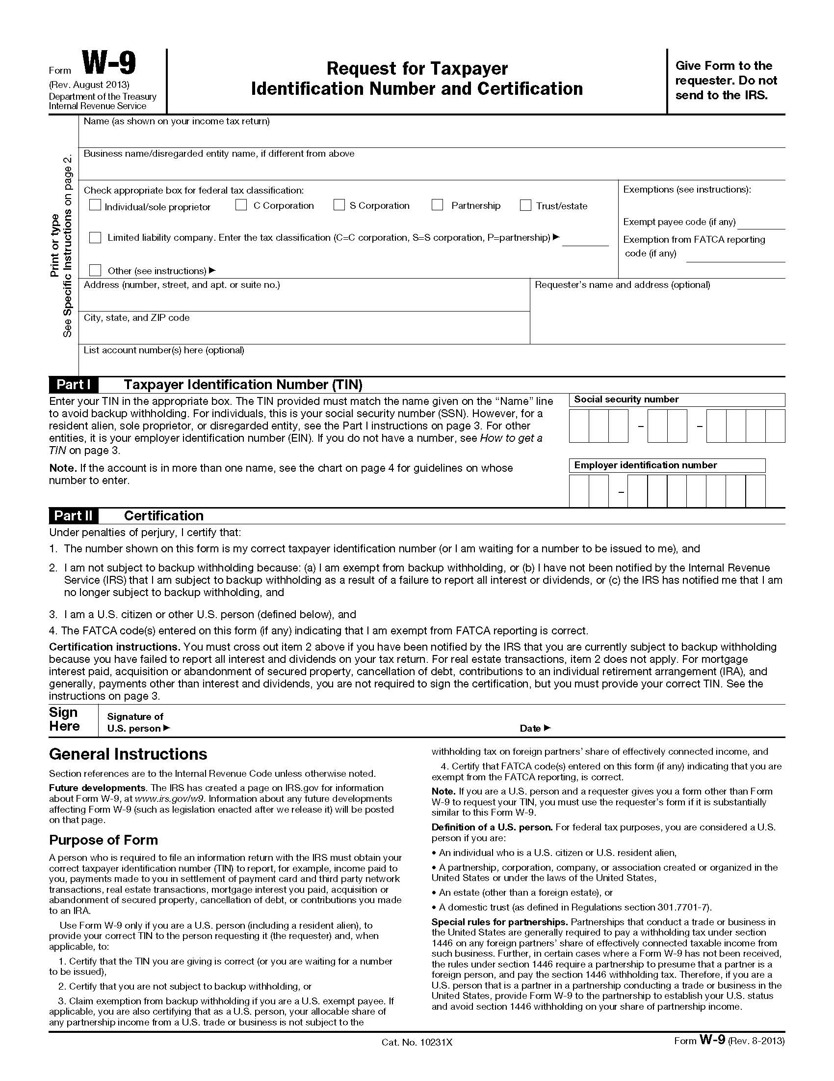

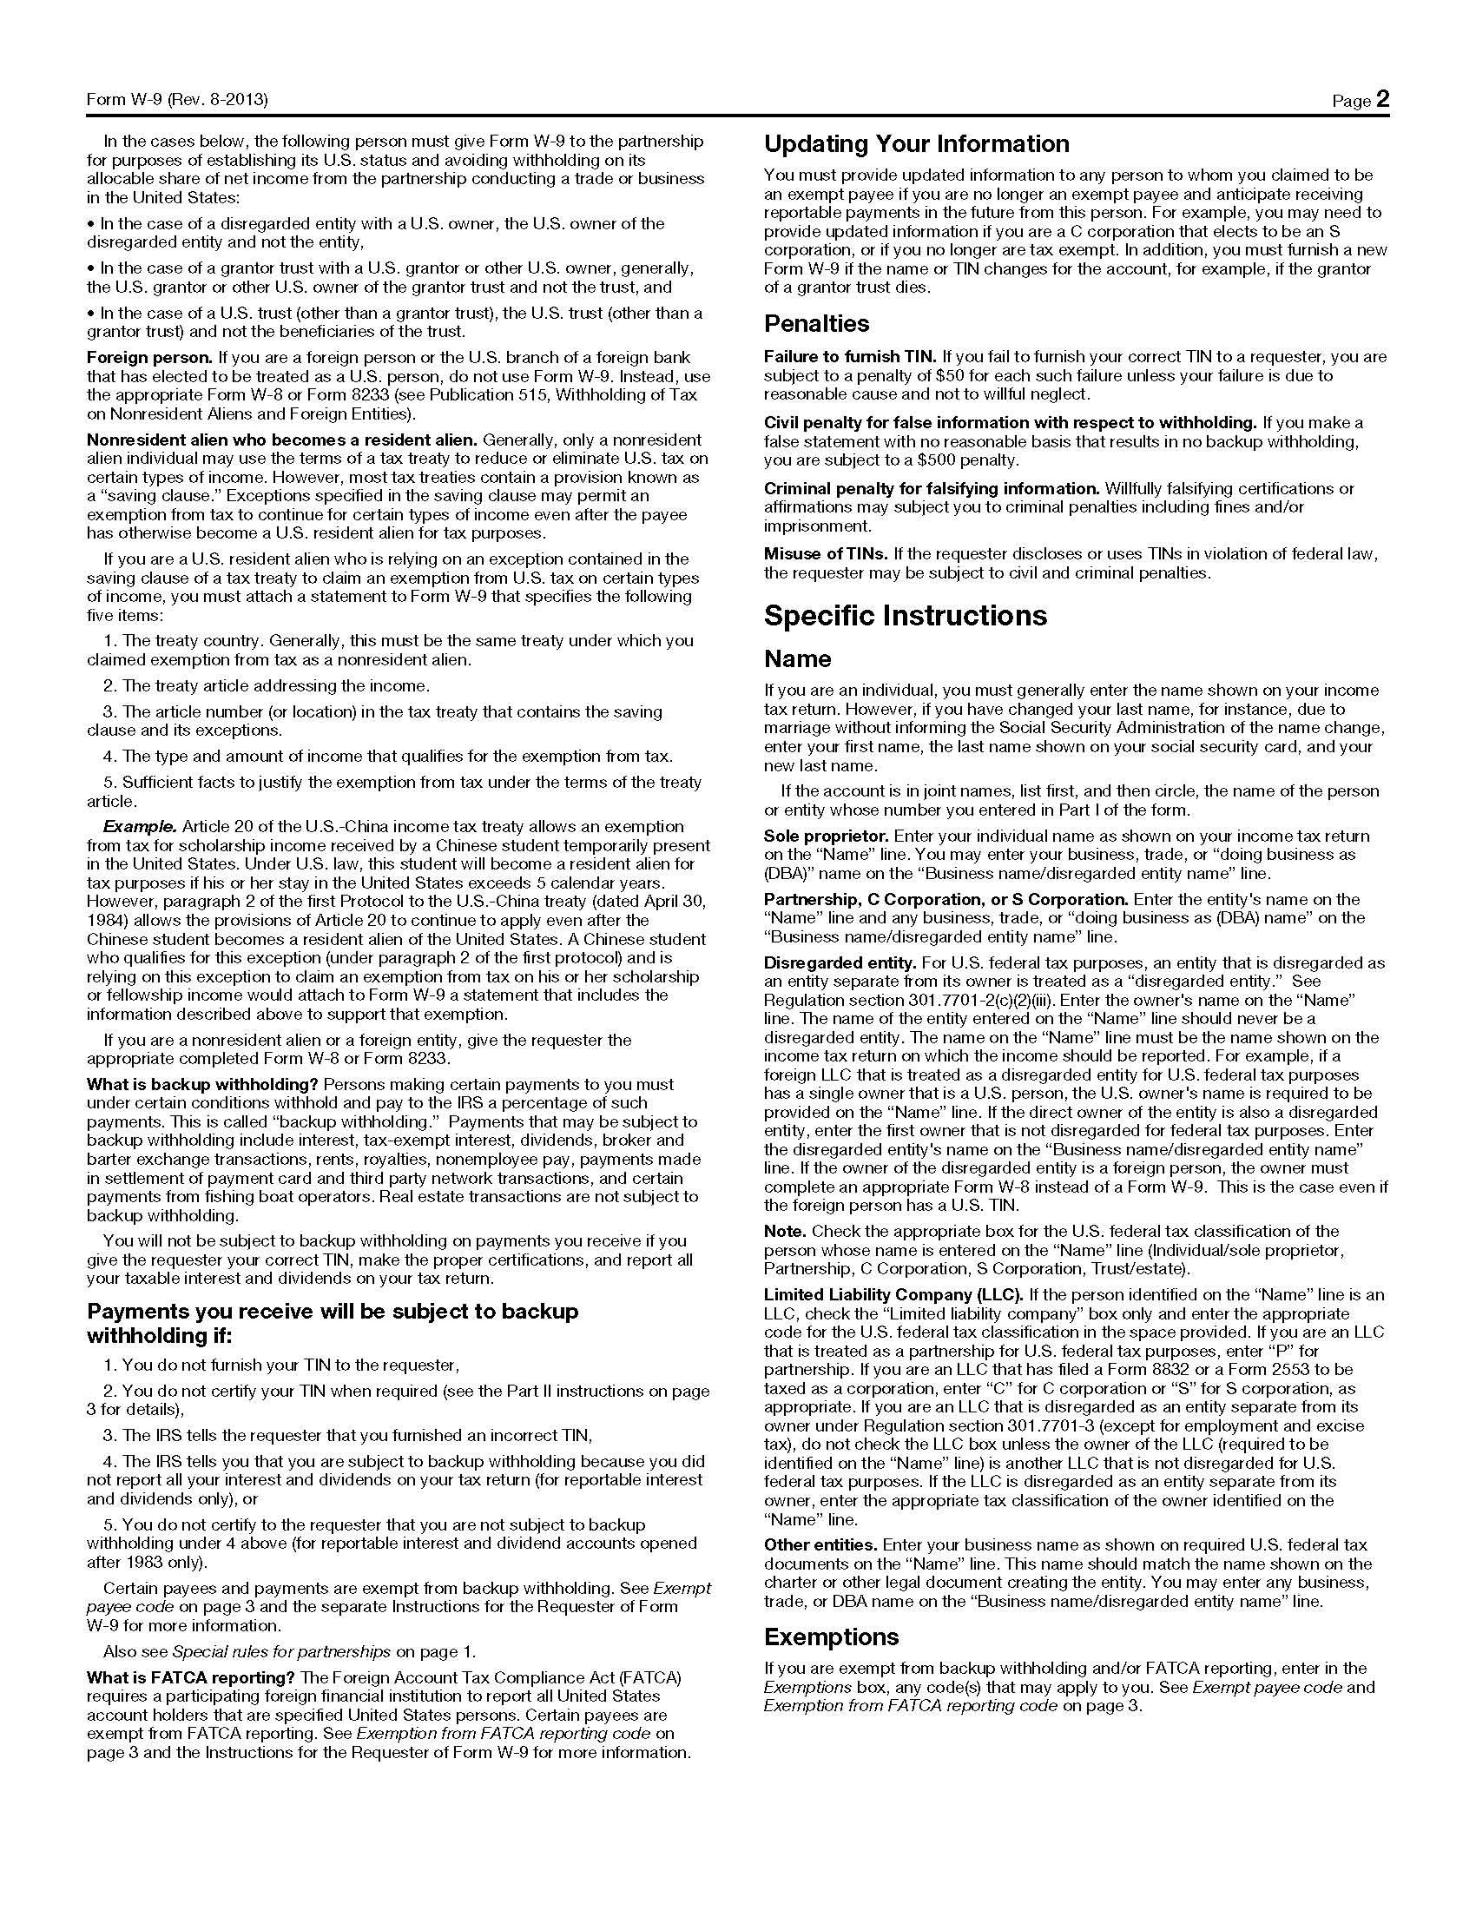

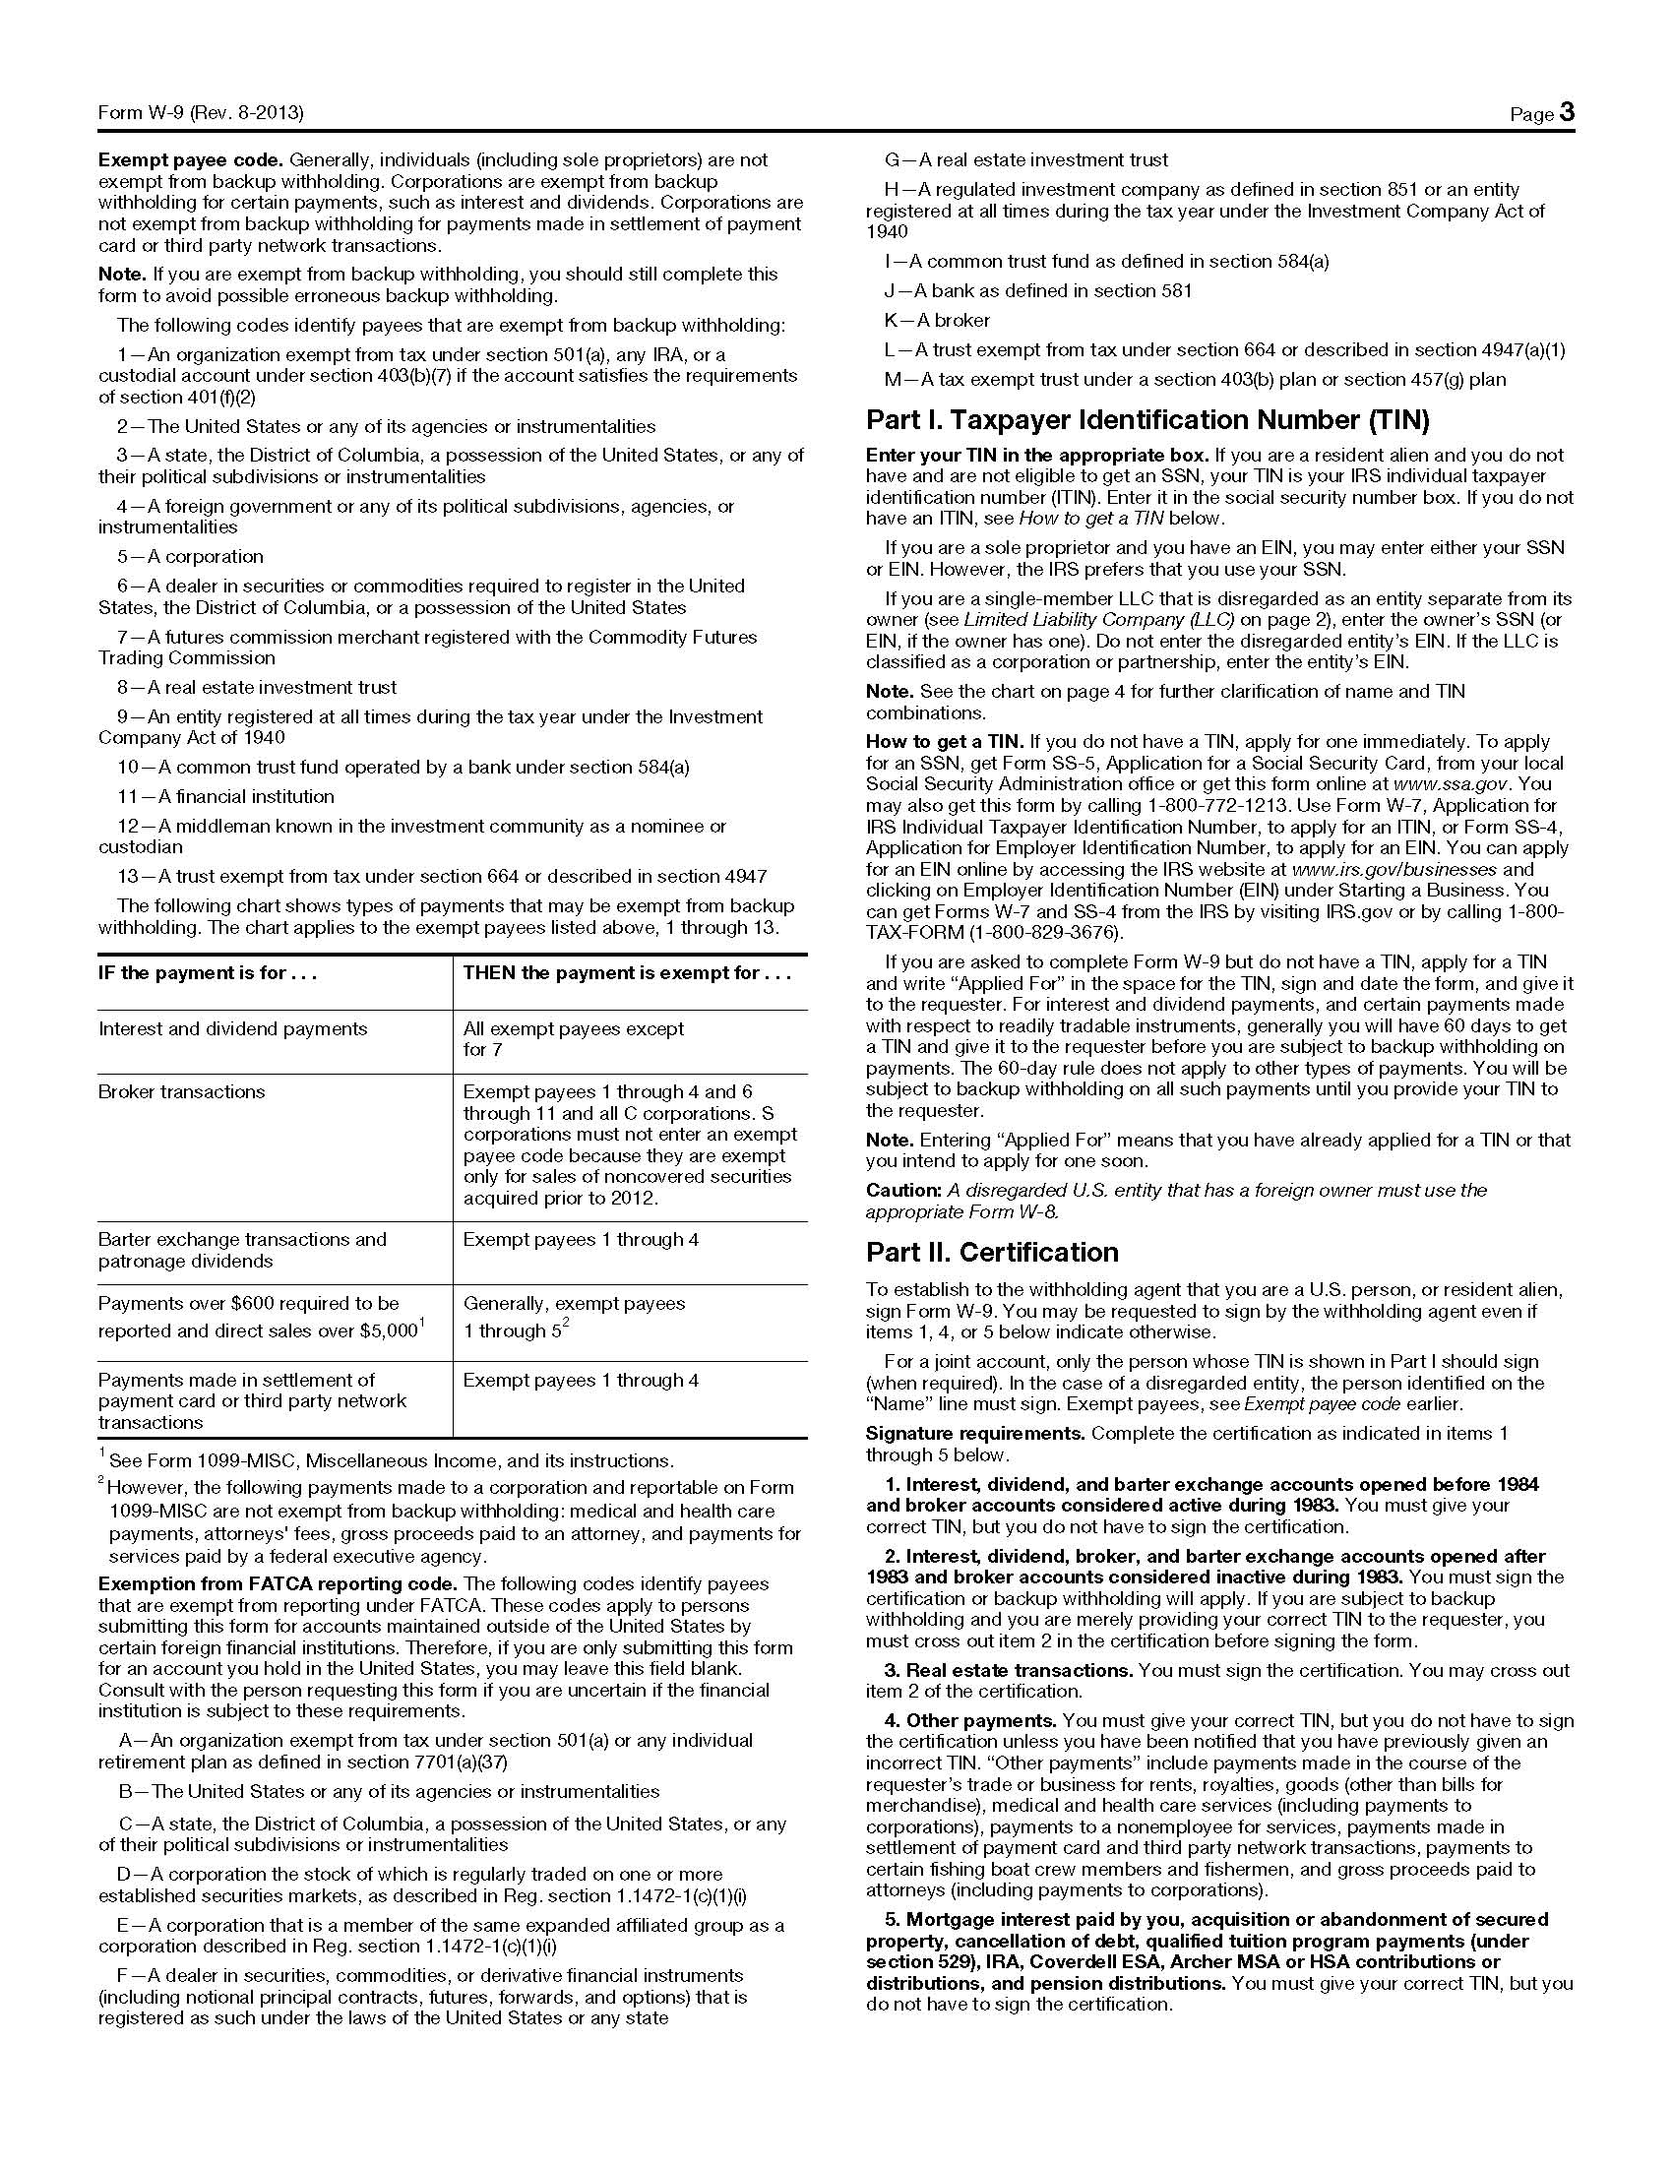

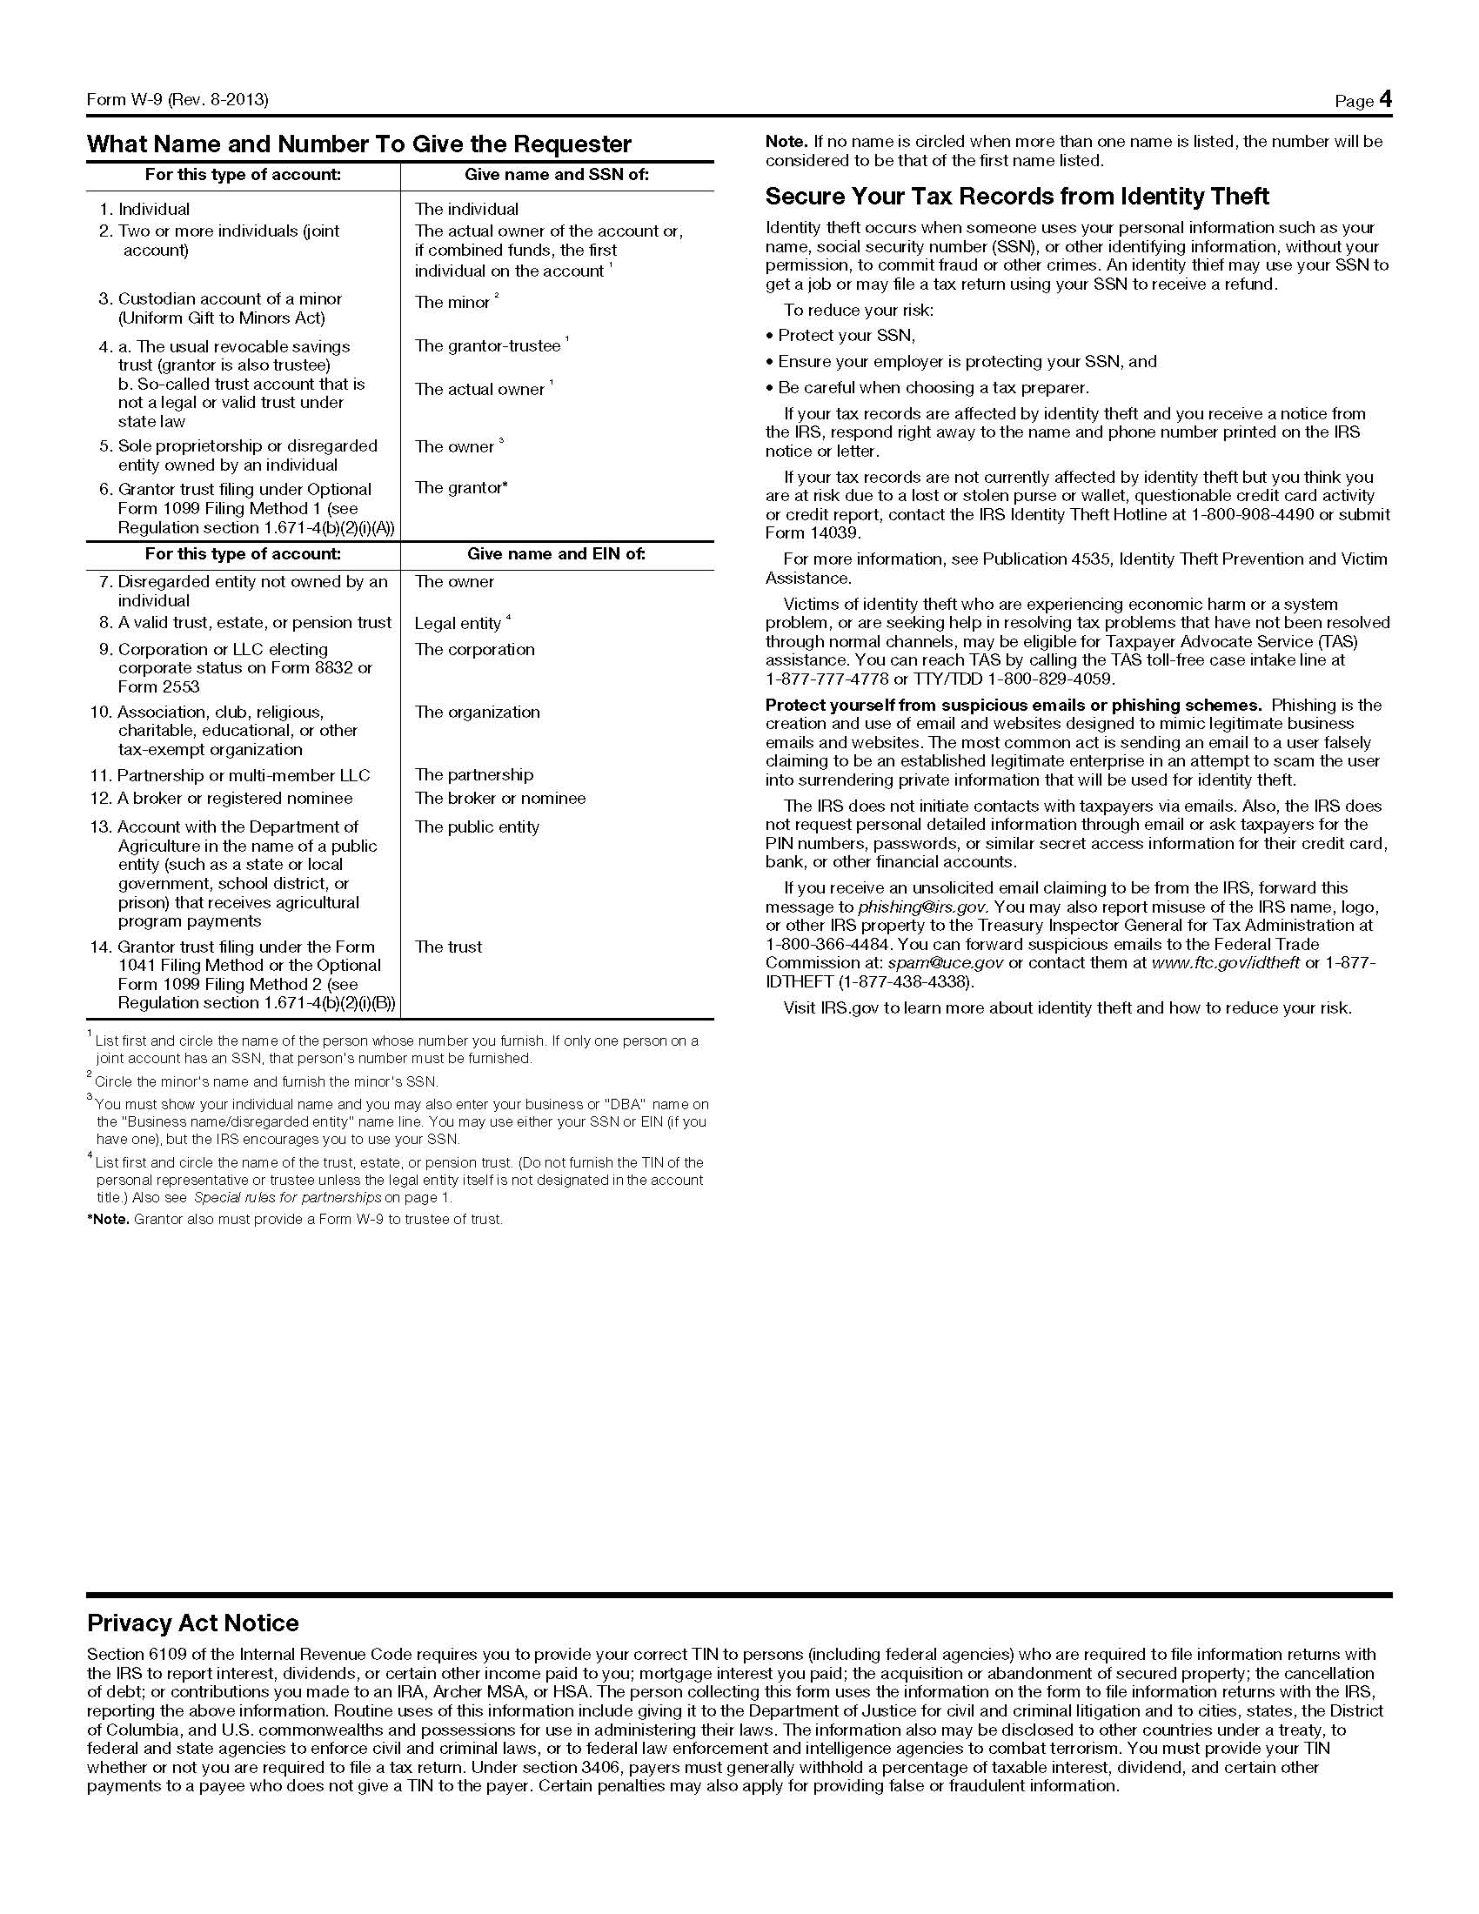Attachment II

TENNESSEE BOARD OF REGENTS

HIGHER EDUCATION SYSTEM

Minority / Ethnicity Form



In order to comply with reporting regulations as required by the State of Tennessee and the United States federal income tax laws, it is necessary that the following information be provided prior to the issuance of any University contract.

|  |  |
| --- | --- |
| 1. Name of Contractor:  _______________________________________  Federal ID / Social Security Number:  _______________________________________ | 2. Is Contractor a US citizen?  Yes  No  If no, state country of citizenship:  ___________________________________________  (If not a US Citizen, please include a copy of Visa with this form.) |
| 3. Kind of Ownership (Check one):  Govt. (GO)  Agency of the State of Tennessee (SA)  Non-Profit (NO)  Majority (MJ)  Minority* (see reverse side for definition)  Woman (WO)** (see reverse side for definition)  Small (SM)*** (see reverse side for definition)  Service-Disabled Veteran****(see reverse side for definition) | 4. Minority / Ethnicity Code (Check One):  African American (MA)  Native American (MN)  Hispanic American (MH)  Asian American (MS)  Other Minority (MO)  Specify: _________ |
| 5. Preference for reporting purposes: (Note: If Contractor qualifies in multiple categories as small, woman-owned and/or minority, Contractor is to specify in which category he / she is to be considered for reporting and classification purposes.)  Small Minority Woman-Owned | |
| 6. Certification: I certify that all the information as completed above is accurate and true.  _____________________________________________________________________________________  Signature Date  Name (Printed): ___________________________________________  Title: _____________________________________________________ | |

\***Minority Ownership Clarification:**

"Minority owned business" means a business that is a continuing, independent, for profit business which performs a commercially useful function, and is at least fifty-one percent (51%) owned and controlled by one (1) or more minority individuals who are impeded from normal entry into the economic mainstream because of past practices of discrimination based on race or ethnic background.

"Minority" means a person who is a citizen or lawful permanent resident of the United States and who is:

a) African American (a person having origins in any of the black racial groups of Africa);

b) Hispanic (a person of Mexican, Puerto Rican, Cuban, Central or South American, or other Spanish culture or origin, regardless of race);

c) Asian American (a person having origins in any of the original peoples of the Far East, Southeast Asia, the Indian subcontinent, or the Pacific Islands); or

d) Native American (a person having origins in any of the original peoples of North America).

**\*\*Woman-Owned Business Clarification:**

A "woman-owned business" means a woman owned business that is a continuing, independent, for profit business which performs a commercially useful function, and is at least fifty-one percent (51%) owned and controlled by one or more women; or, in the case of any publicly owned business, at least fifty-one percent (51%) of the stock of which is owned and controlled by one (1) or more women and whose management and daily business operations are under the control of one (1) or more women.

**\*\*\*Small Business Ownership Clarification:**

A "small business" means a business that is independently owned and operated for profit, is not dominant in its field of operation and is not an affiliate or subsidiary of a business dominant in its field of operation.

The Governor's Office of Diversity Business Enterprise establishes small business guidelines on industry size standards. The criteria guidelines are required to be met in order for a business to be considered small. The annual receipts or number of employees indicates the maximum allowed for a small business concern and its affiliates to be considered small.

|  |  |  |
| --- | --- | --- |
| **TYPE OF BUSINESS** | **ANNUAL GROSS SALES** | **NO. OF EMPLOYEES** |
| Agriculture, Forestry, Fishing | $500,000 | 9 |
| Architectural / Design / Engineering | $2,000,000 | 30 |
| Construction | $2,000,000 | 30 |
| Educational | $1,000,000 | 9 |
| Finance, Insurance & Real Estate | $1,000,000 | 9 |
| Information Systems / Technology | $2,000,000 | 30 |
| Manufacturing | $2,000,000 | 99 |
| Marketing / Communications / Public Relations | $2,000,000 | 30 |
| Medical / Healthcare | $2,000,000 | 30 |
| Mining | $1,000,000 | 49 |
| Retail Trade | $750,000 | 9 |
| Service Industry | $500,000 | 9 |
| Transportation, Commerce & Utilities | $1,000,000 | 9 |
| Wholesale Trade | $1,000,000 | 19 |